TVA Par défaut
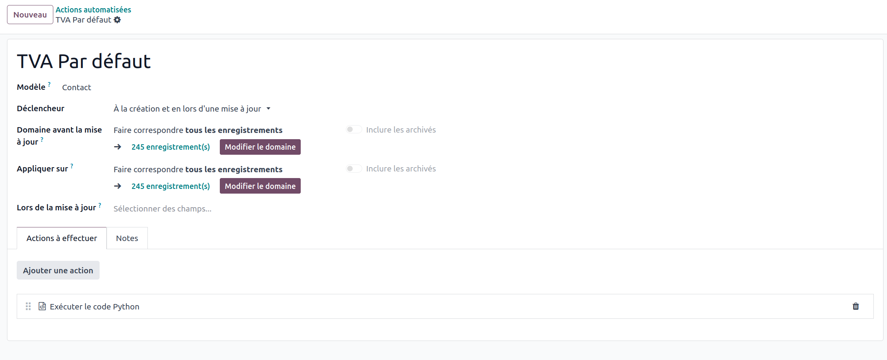
for test in records:
if not test.property_account_position_id:
tva_id = env['account.fiscal.position'].search([('name', '=', 'Régime National')], limit=1)
if tva_id:
test.write({
'property_account_position_id': tva_id,
})

