Gandi LiveDNS Config
Password = API KEY
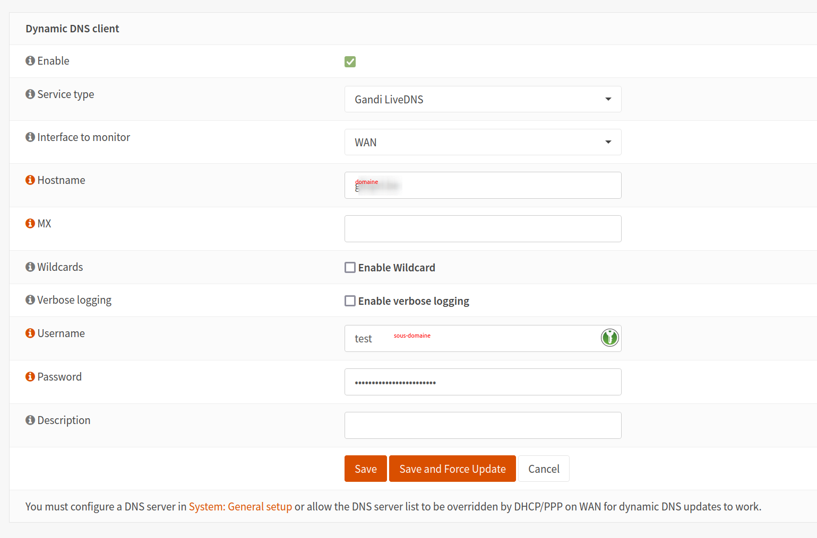

Mettre à jour manuellement via CURL
curl -X PUT https://api.gandi.net/v5/livedns/domains/DOMAIN.be/records/ARECORD-H 'authorization: Apikey APIKEYABCDEFGHIKJKJFKJF' -H 'content-type: application/json' -d '{"items":[{"rrset_type":"A","rrset_ttl":"300","rrset_values":["1.2.3.4"]}]}'

