Cals
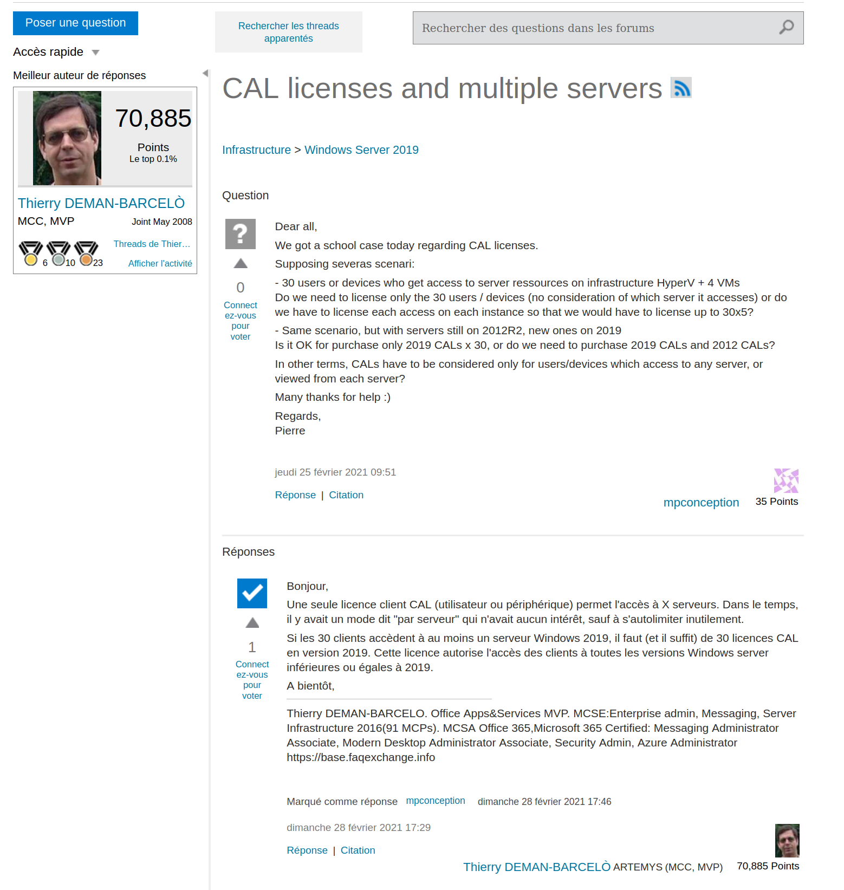 https://social.technet.microsoft.com/Forums/windows/fr-FR/cbe2d031-0457-4902-876b-e0dc38936406/cal-licenses-and-multiple-servers?forum=ws19fr

